**EXHAUSTIVE ANALYSIS OF INDIAN AGRICULTURE USING POWER BI (Task 1)**

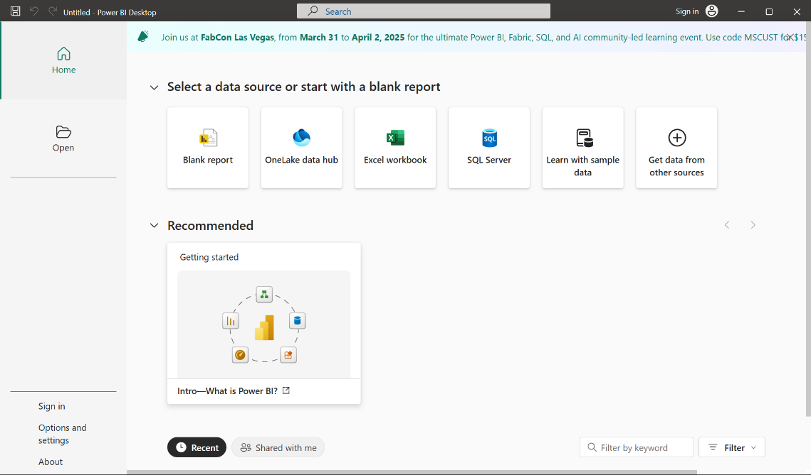**Step 1:** To download Power BI, Visit this link:<https://www.microsoft.com/en-us/download/details.aspx?id=58494>  
  
**Step 2:** After Finishing the download process, The Power BI welcome page appears to be like this:

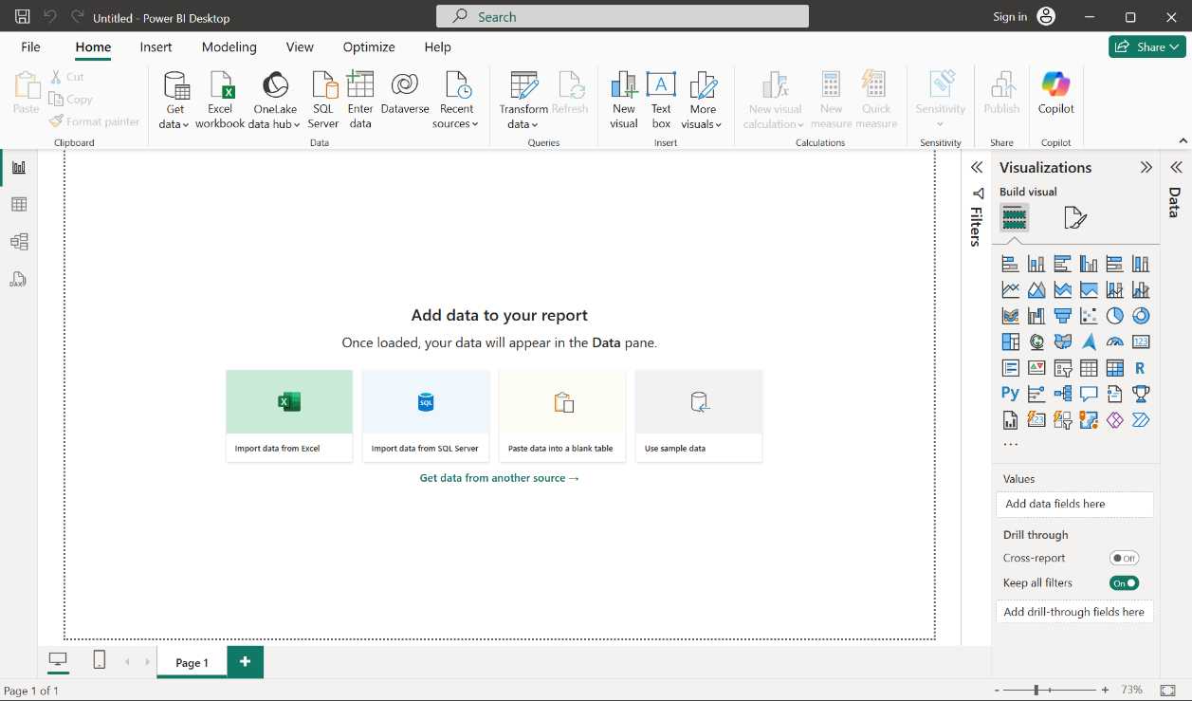**Step 3:** Click on **Blank Report**, which will open a Canvas, where you can create different visualizations. The window after clicking on blank report should appear like this:

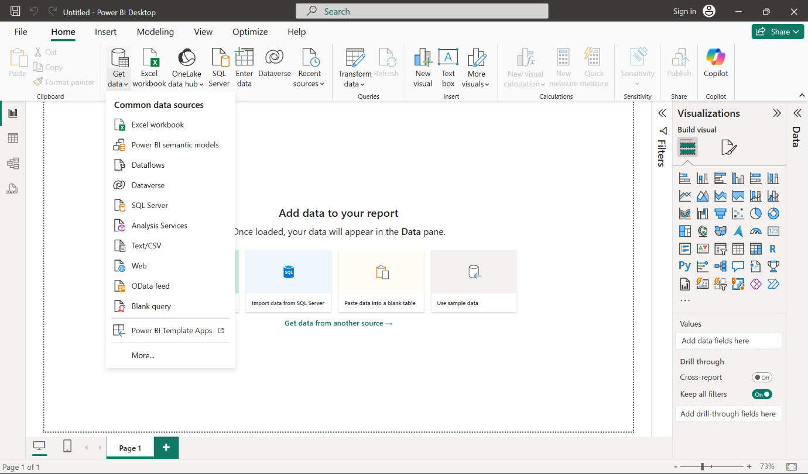**Step 4:** Extracting data, To extract data from a data source: excel, csv, text files etc. Select **Get data,** and Select your file type:

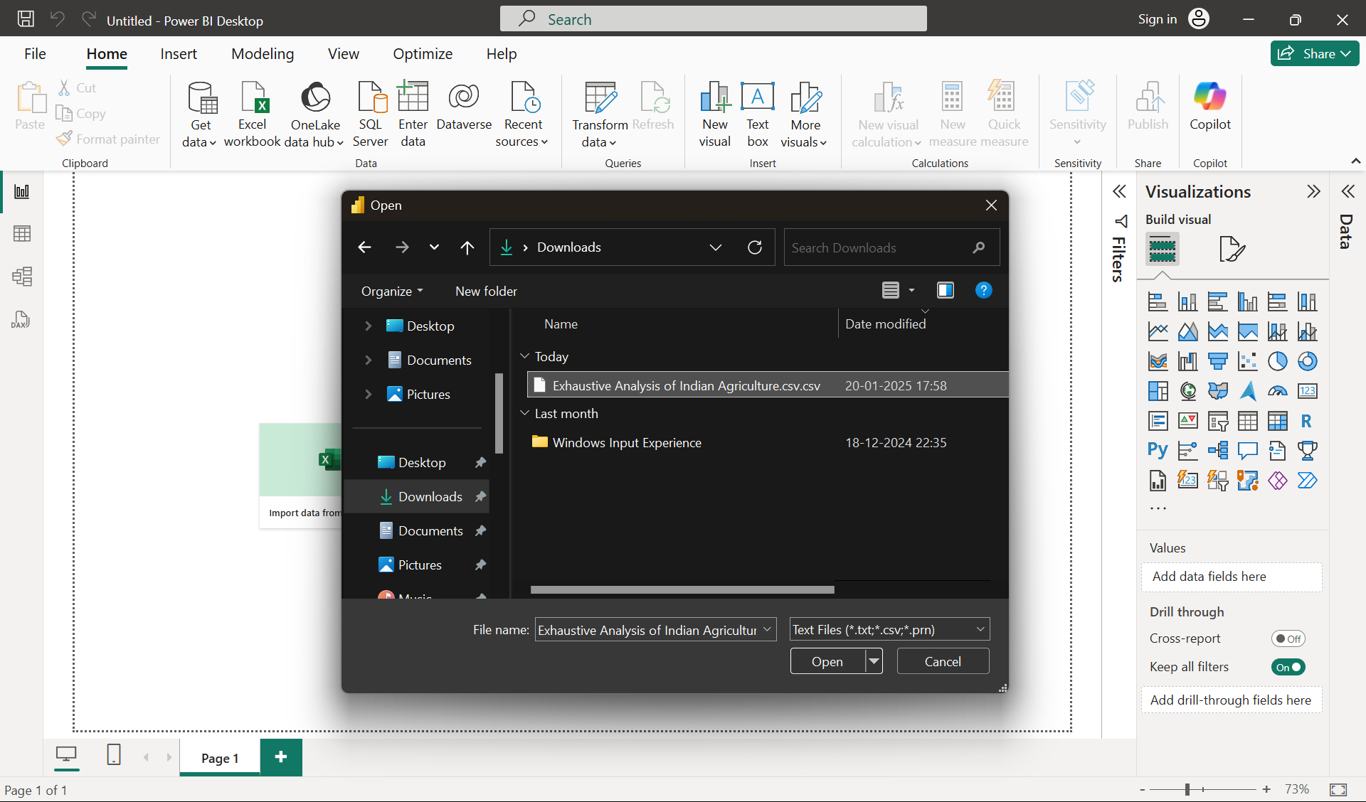**Step 5:** After selecting the type of File, (Here csv file) it should appear like this,(then click on **Open**)

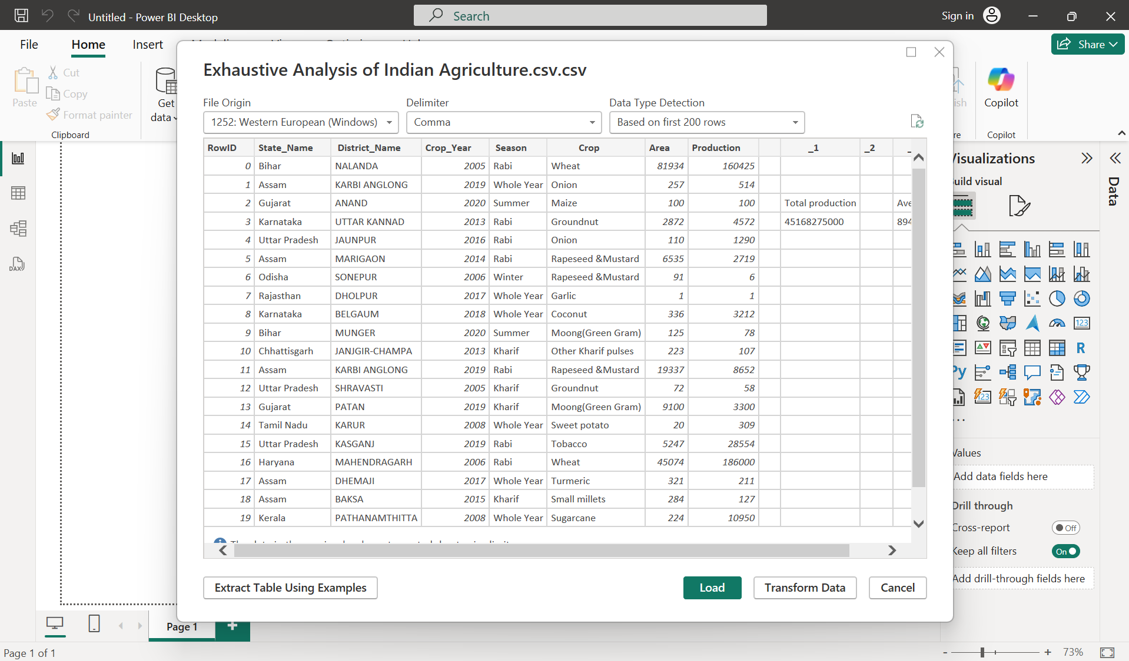**Step 6:** After clicking on “**Open**”, a window should appear like so:

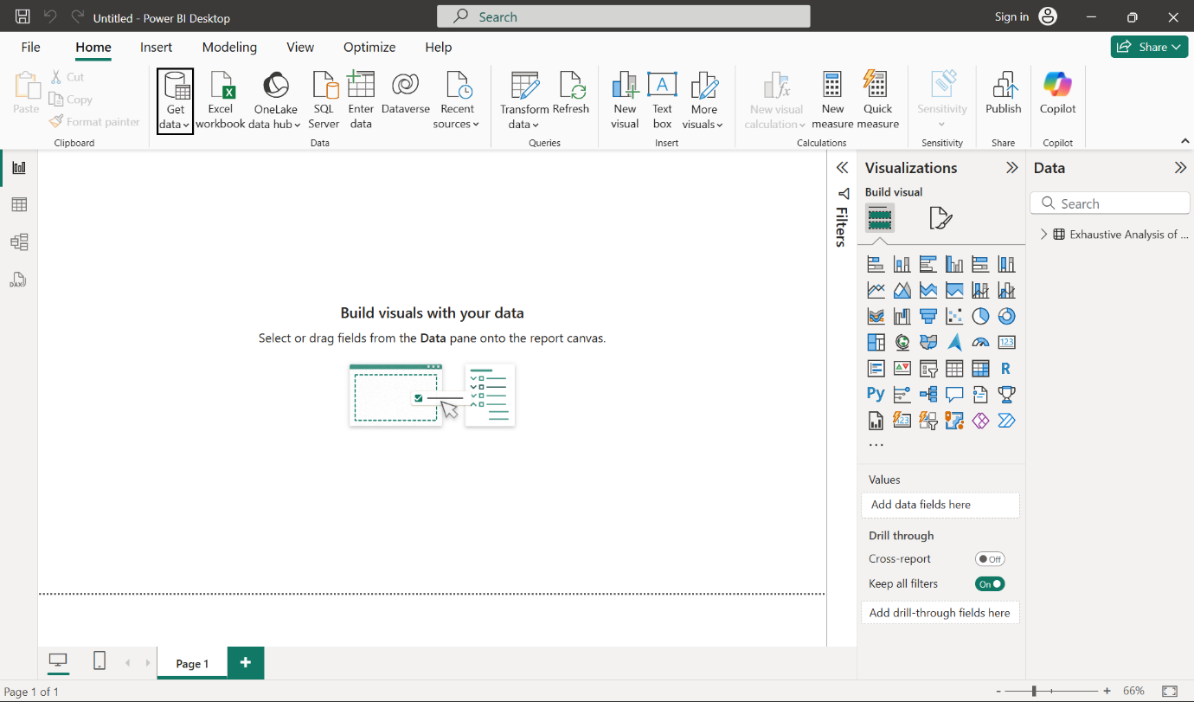**Step 7**: Select “**Load”** (Load the data if the data is cleaned) Select “**Transform**” (Transform the data when the data needs processed/cleaned).   
**Step 8:** Click “**Load**”. After you click on load it should appear like this (shows that data is loaded)

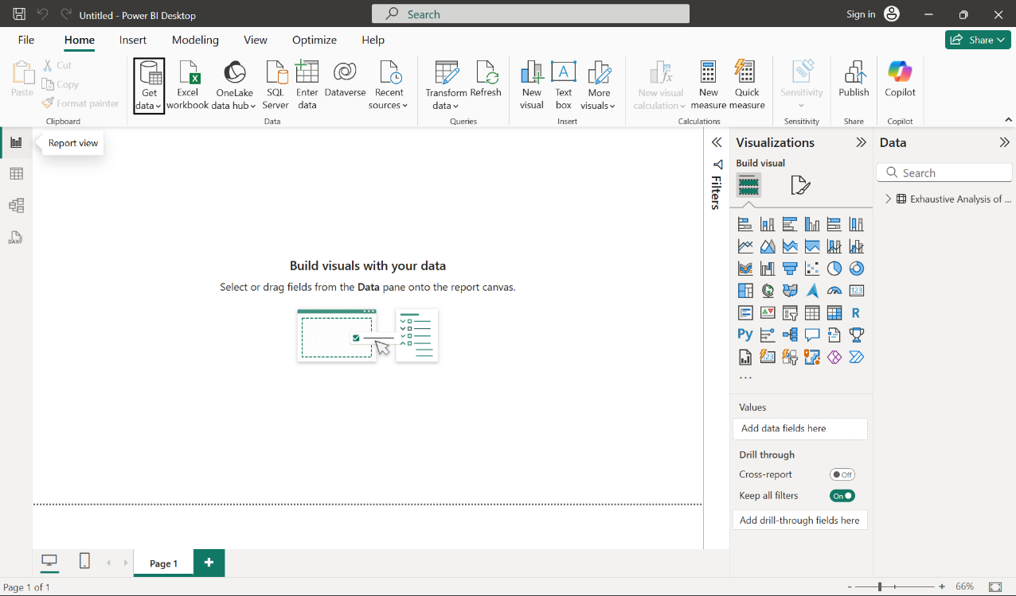**Step 9: Three Views of Power BI Desktop which we will be using:   
Report view:** It is a visual interface in Power BI for creating and designing interactive reports with charts, graphs, and other visualizations.

**Table view:** Displays the data in Tabular Format.

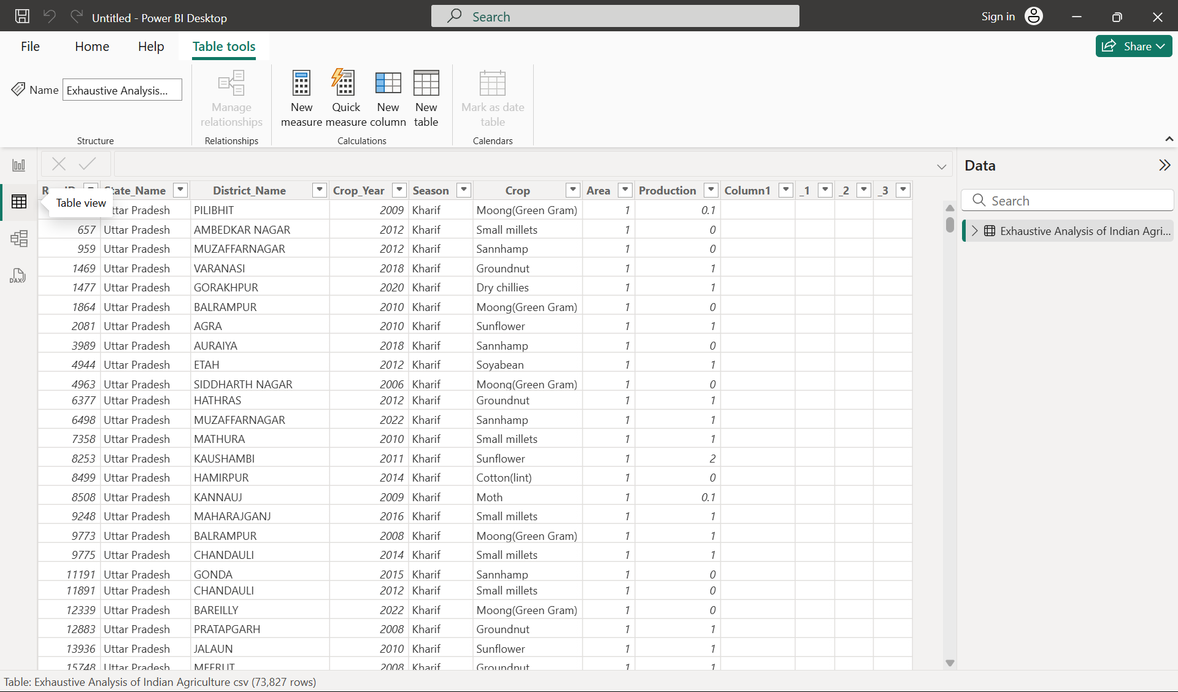

**Model view:** For defining and managing relationships among data.

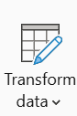**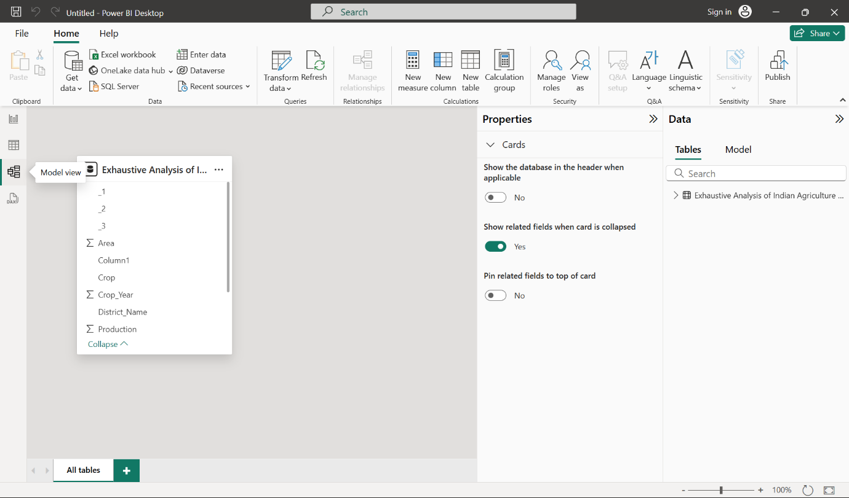Step 10: Transform the data**: To transform the data click on “**Transform Data**” in Home Tab(in Report view). After clicking, It should open a “**Power Query Editor**” window.  
**Power Query Editor** is data transformation tool in Power BI used to connect, clean, and shape data before loading it into the data model.

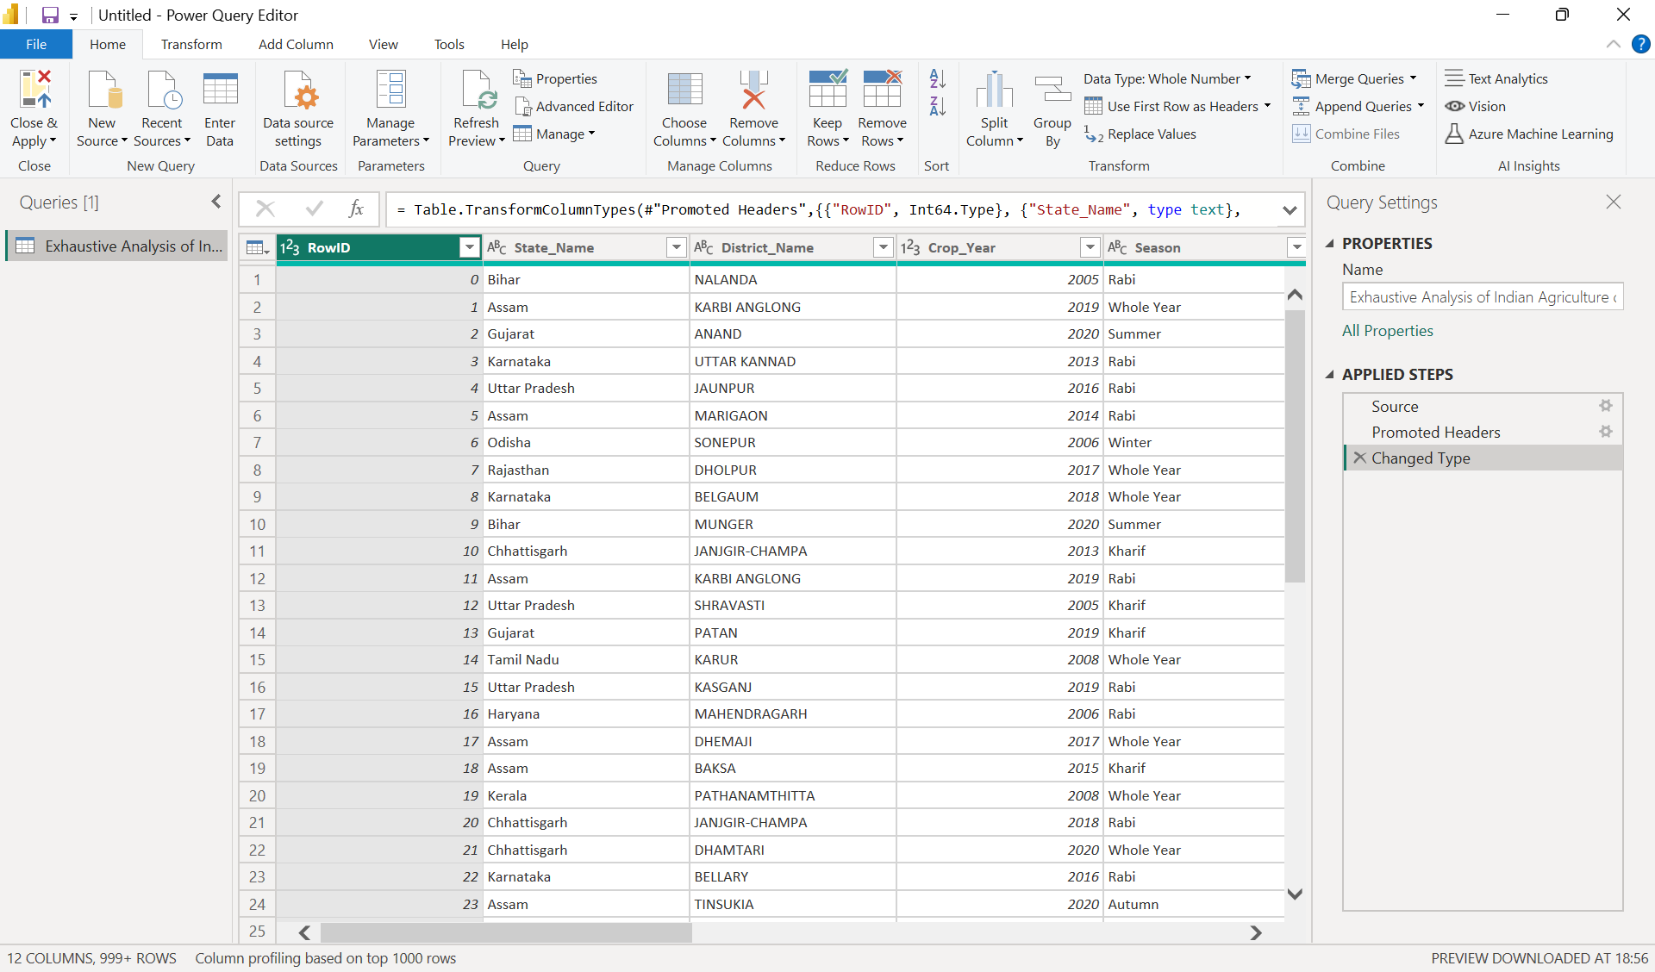

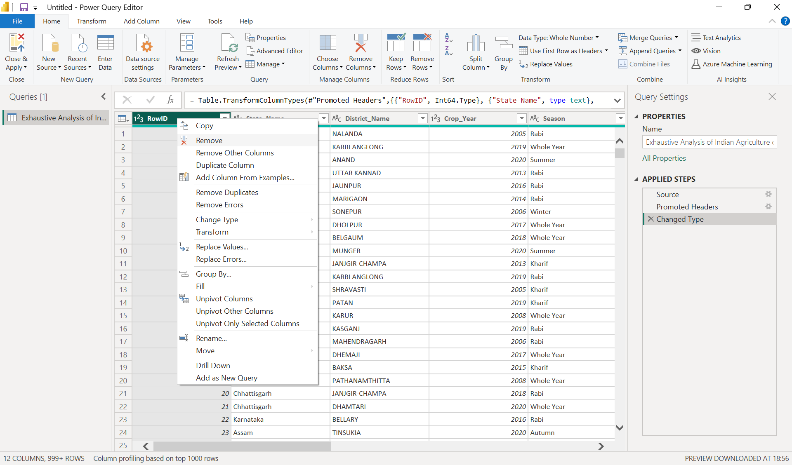**Step 11: Remove Unnecessary Columns:** Removing Row Id, as it is not needed for us to generate any visualizations. Select “**RowID**” Column and right click and click on “**Remove**”.

**Step 12:** **After** Selecting “**Remove**”. It **shows** on the “**Applied steps**” on the right side.

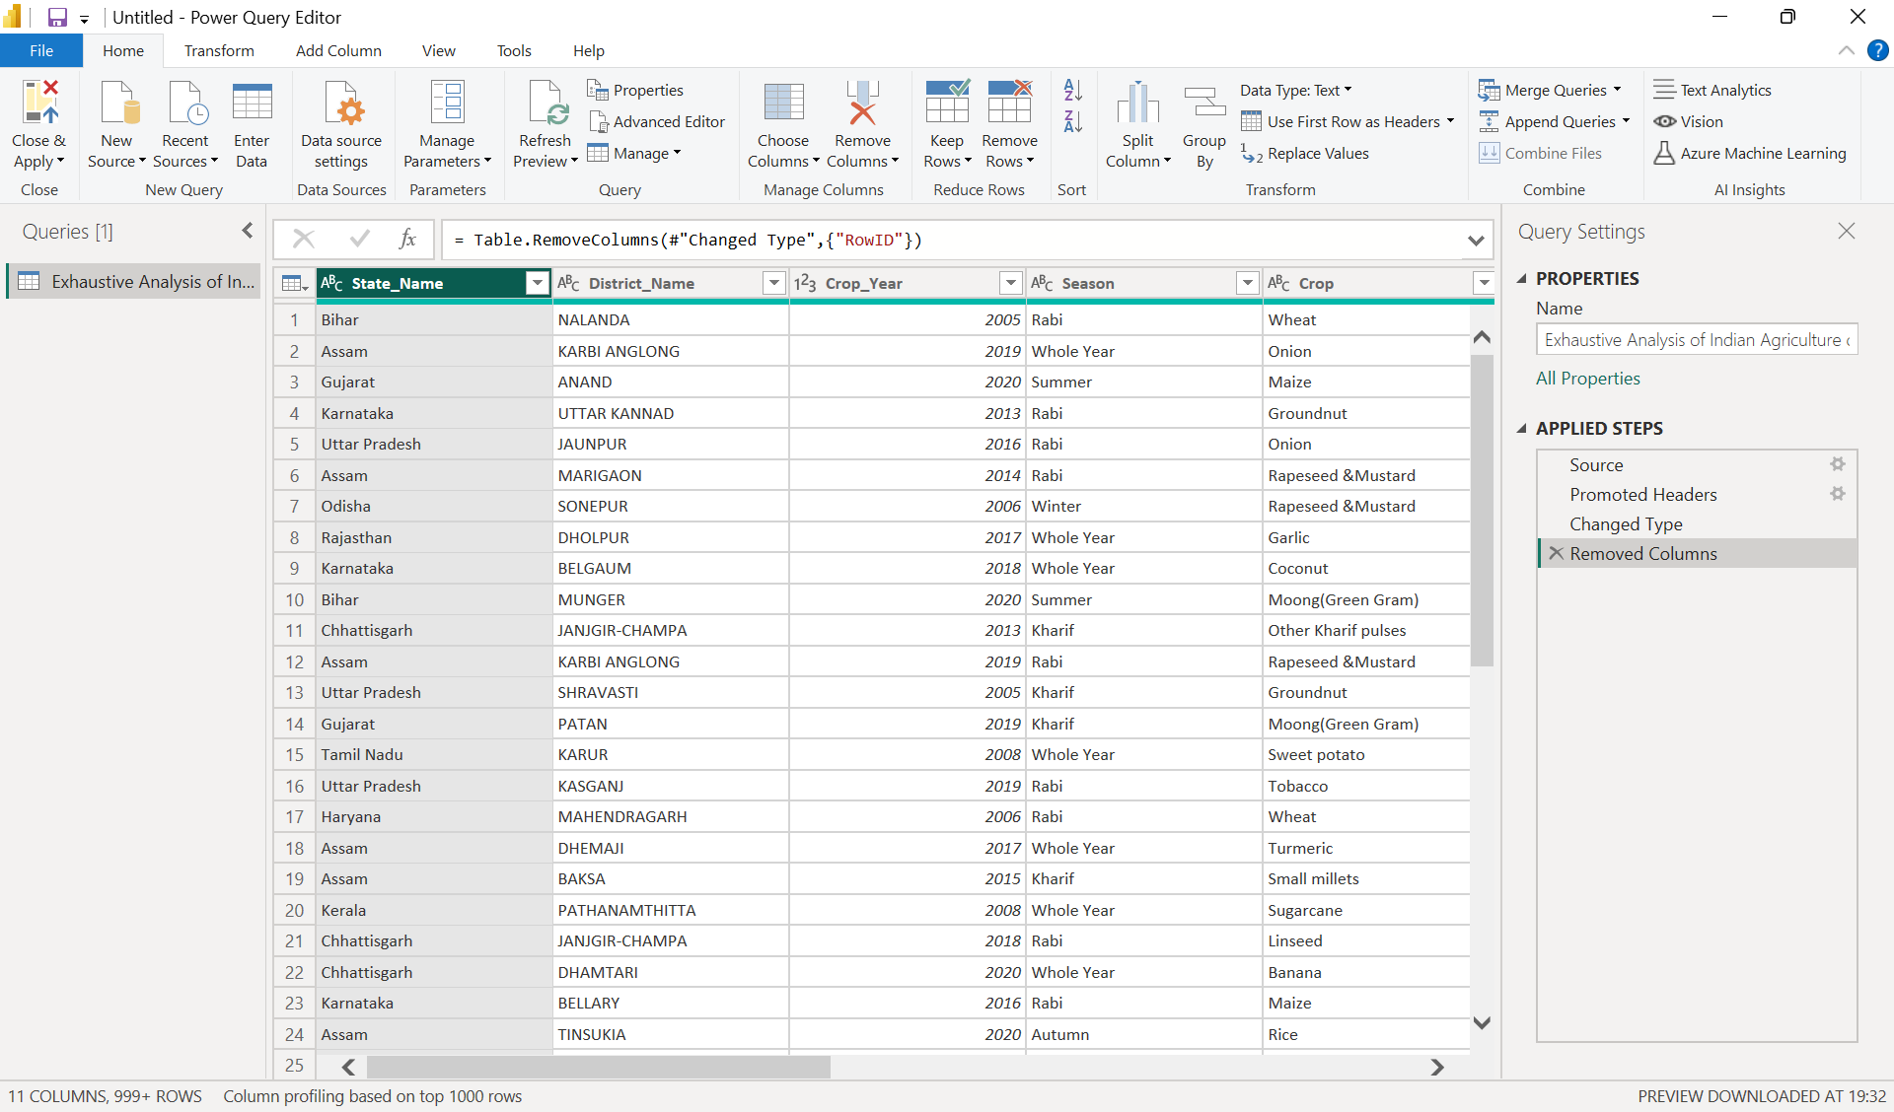

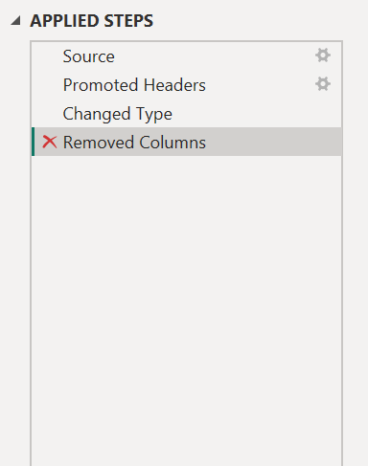**Step 13:** If you want to undo the changes you performed to the data, select the **“X”** Beside the **“Removed Columns”** in “**APPLIED STEPS**”.  
After clicking, it should undo the changes.

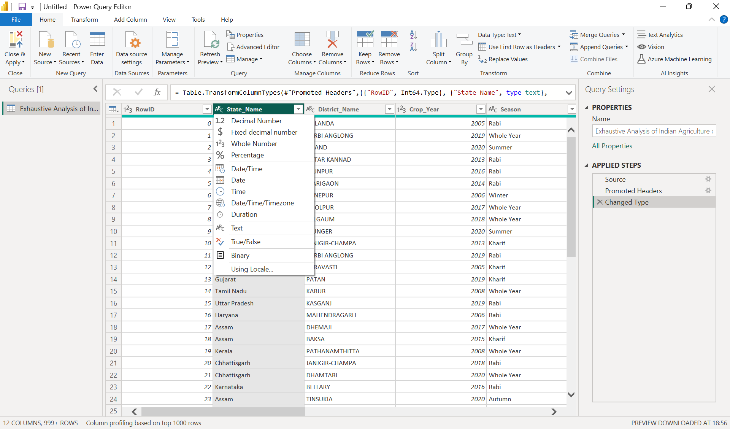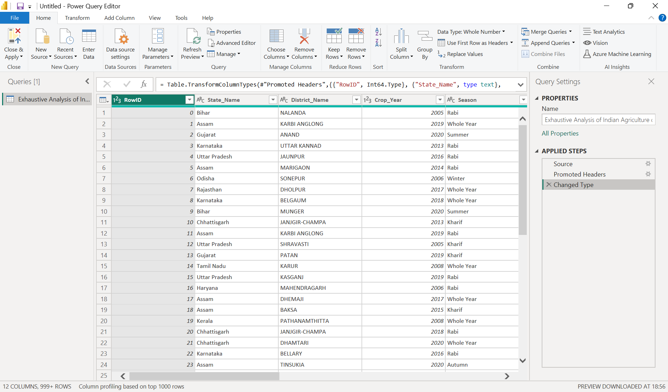**Step 14:** To display the what the data of a particular column holds just **Select** **the column**, It should display if the data is in **Text, Decimal numbers, Whole numbers, Percentage** etc.

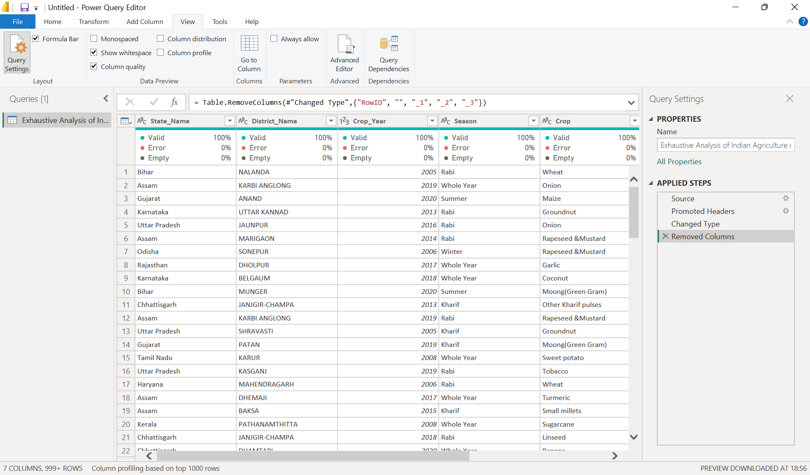**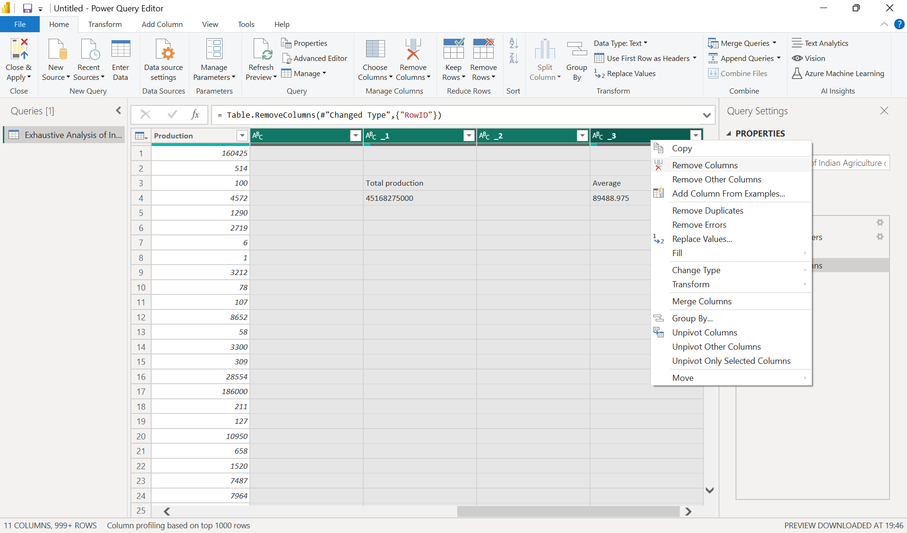Step 15:** Following the same Step 11, we can remove multiple useless columns**, Ctrl+Select**(To select more than one column)and **Right click** and **select “Remove Columns”.  
  
  
  
  
  
  
  
  
  
  
  
  
  
  
  
  
  
  
  
Step 16:** To view If the column is error free, or has no null/empty values, go to **“View”** tab at the top. **Select “Column quality” option.** The **Column Quality option** in the View tab of Power Query Editor **displays** a visual summary of the data quality for each column, including the **percentage of Valid, Error, and Empty values**.

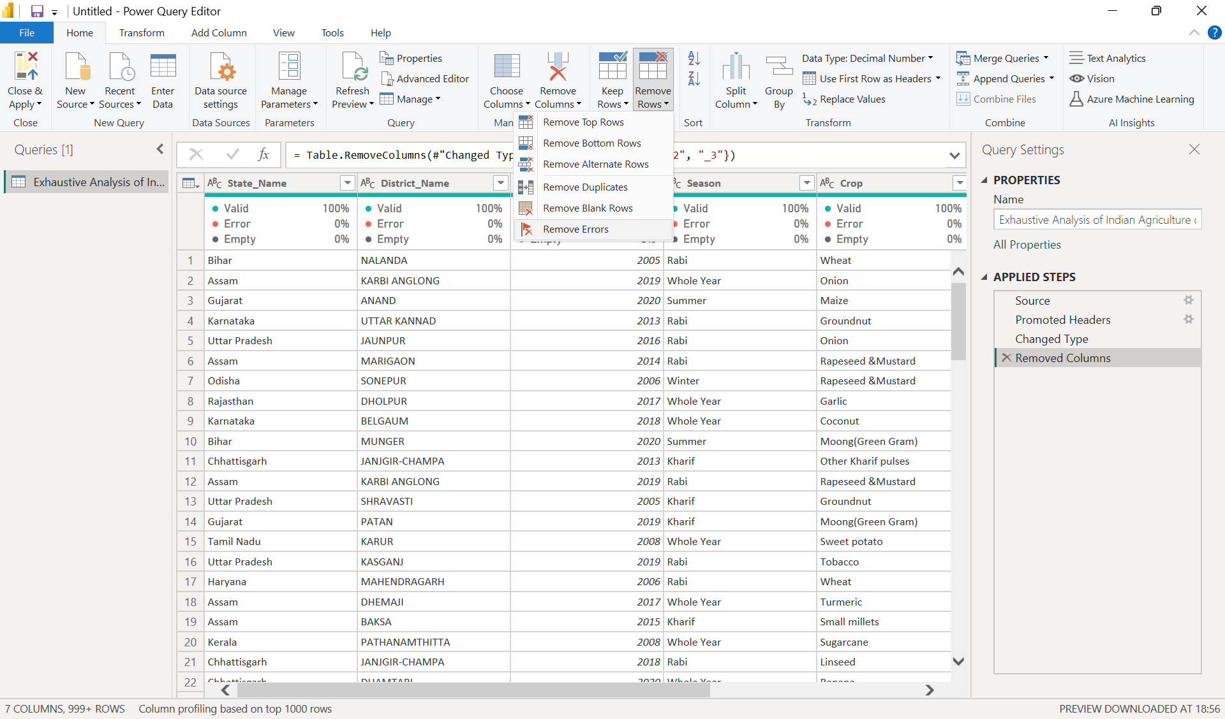**Step 17:** If we want to remove any rows, which contain **duplicates, errors, null values. Select “Remove rows”** in Home tab and select any of the options (not choosing anything because it is already cleaned).

**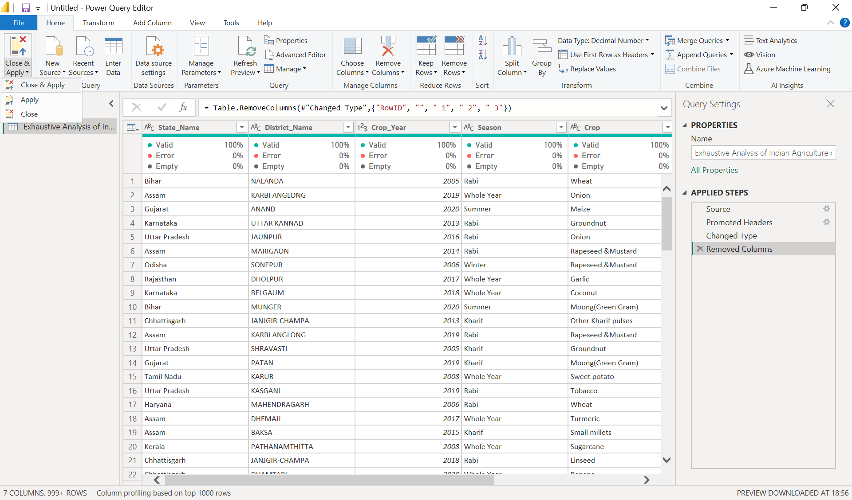  
  
  
  
  
  
  
  
  
  
  
  
Step 18:** Once the data has no errors, null values or duplicates**. Click on “Close & Apply” Option, in Home Tab**. (Top Left corner) This will reflect all the changes we made to the data.

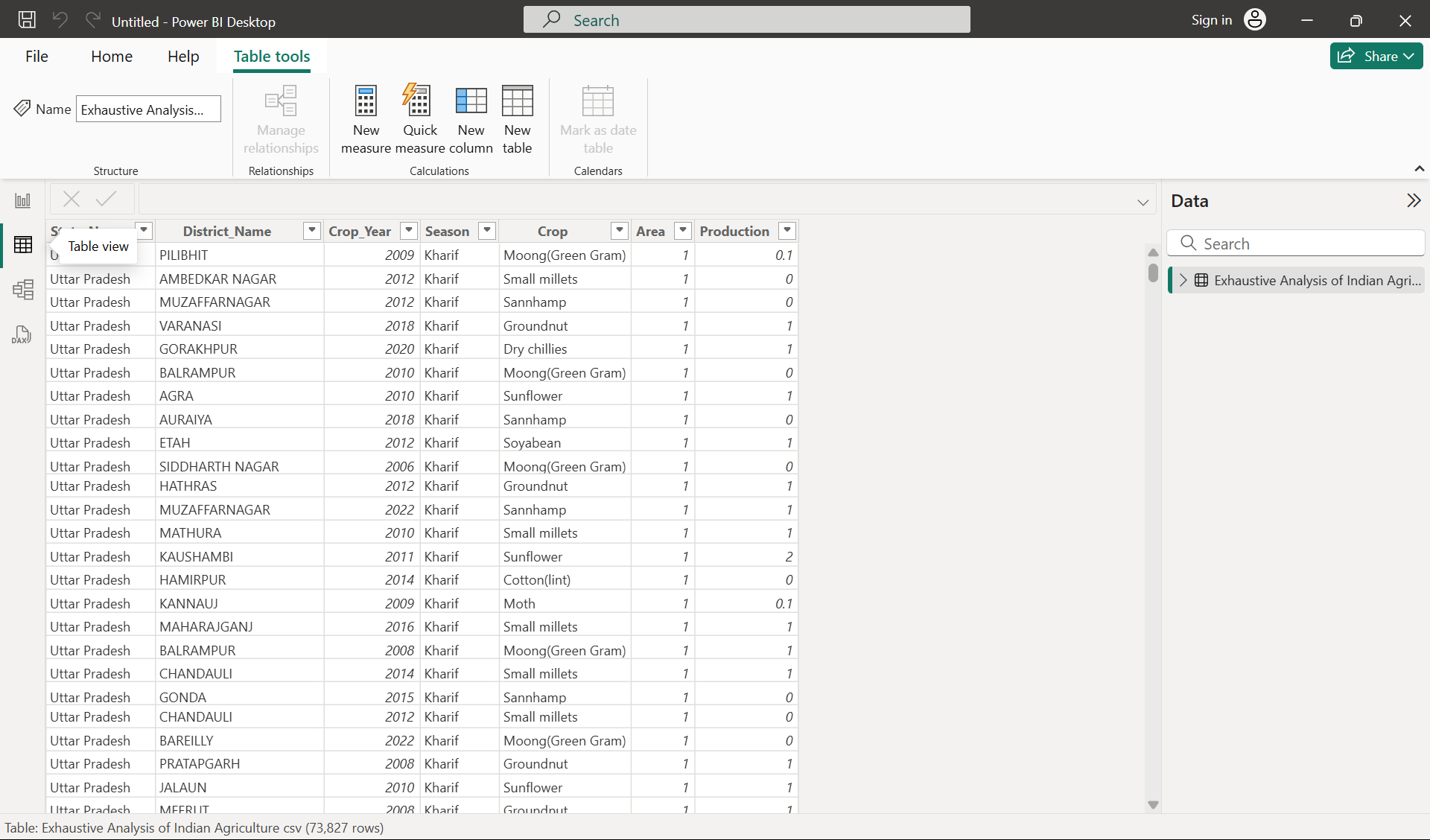**Step 19:** Your changes should now be applied. You can view the table in the **“Table View”**